**How to use multiple desktops in Windows 10**

**How to create a new virtual desktop in Windows 10**

Creating a new virtual desktop can be done with a couple of clicks or with a keyboard shortcut.

1. Click the **Task View** button in your taskbar.
   * You can also use the **Windows key + Tab** shortcut on your keyboard, or you can swipe with one finger from the left of your touchscreen.
2. Click **New Desktop**. (It's located in the top left corner of your screen.)

[](https://www.windowscentral.com/sites/wpcentral.com/files/styles/xlarge/public/field/image/2018/07/windows-10-virtual-desktop-update-create-01.jpeg?itok=YHVZJUcN)

That's it. Easy, right? There's also a **Ctrl + Windows key + D** keyboard shortcut that will immediately create a new virtual desktop.

**How to switch between virtual desktops in Windows 10**

Now that you've created a new virtual desktop, you can quickly switch a few different ways.

1. Click the **Task View** button in your taskbar.
   * You can also use the **Windows key + Tab** shortcut on your keyboard, or you can swipe with one finger from the left of your touchscreen.
2. Click **Desktop 2** or any other virtual desktop you've created.

[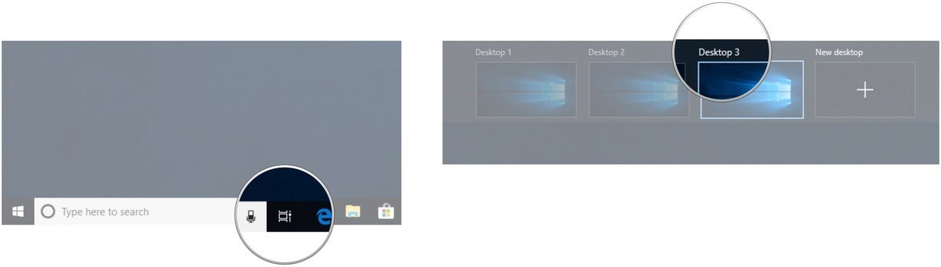](https://www.windowscentral.com/sites/wpcentral.com/files/styles/xlarge/public/field/image/2018/07/windows-10-virtual-desktop-update-switch-01.jpeg?itok=ClLjRN2a)

You can switch back to your original desktop at any time by following the above steps but choosing Desktop 1. There's also a **Ctrl + Windows key + Left and right arrow** keyboard shortcut that you can use to switch between virtual desktops. Using a device with a touchpad? You can perform a **four-finger swipe** left or right to switch between virtual desktops.

[**Best online learning tools for kids: ABCmouse, Reading IQ, & more**](https://www.androidcentral.com/best-online-learning-tools-kids)

**How to move windows between virtual desktops in Windows 10**

There are two ways you can move windows between virtual desktops. First, you can click and drag windows; second, you can right-click the window and use the menu.

**Click-and-drag method**

1. Click the **Task View** button in your taskbar.
   * You can also use the **Windows key + Tab** shortcut on your keyboard, or you can swipe with one finger from the left of your touchscreen.
2. Click and hold the **window** you want to move.
3. Drag and release the **window** on an **alternate desktop**.

[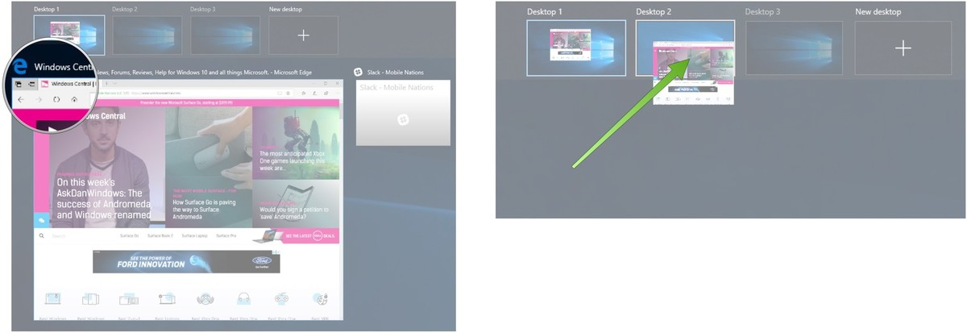](https://www.windowscentral.com/sites/wpcentral.com/files/styles/xlarge/public/field/image/2018/07/windows-10-virtual-desktop-update-drag-01.jpeg?itok=GGa6Tx3S)

**Right-click menu method**

1. Click the **Task View** button in your taskbar.
   * You can also use the **Windows key + Tab** shortcut on your keyboard, or you can swipe with one finger from the left of your touchscreen.
2. Right-click on the **window** you'd like to move to another desktop.

[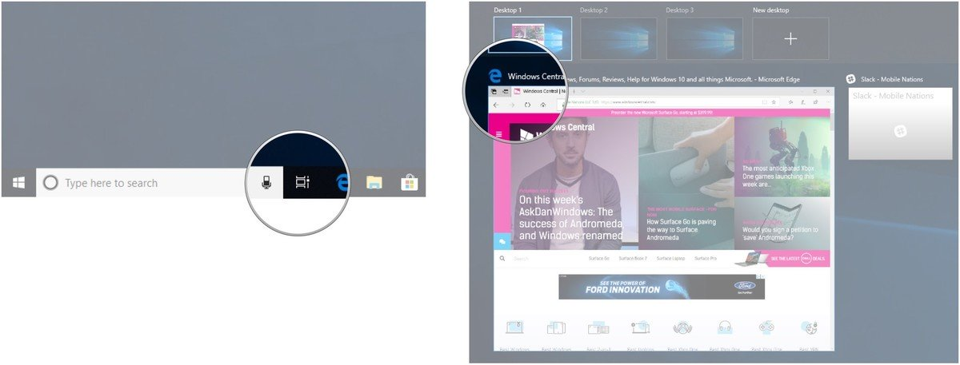](https://www.windowscentral.com/sites/wpcentral.com/files/styles/xlarge/public/field/image/2018/07/windows-10-virtual-desktop-update-click-01.jpeg?itok=DUn5spqn)

1. Hover your **cursor** over **Move to**.
2. Click the **desktop** to which you'd like to move the window.

[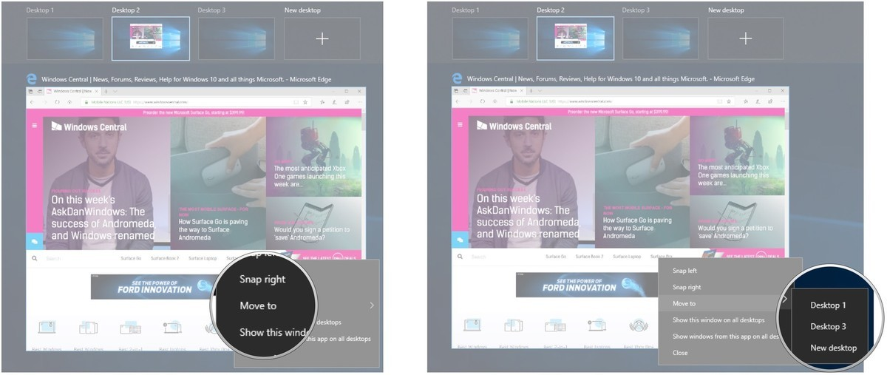](https://www.windowscentral.com/sites/wpcentral.com/files/styles/xlarge/public/field/image/2018/07/windows-10-virtual-desktop-update-click-02.jpeg?itok=5lGvhgNd)

You can move windows back and forth between desktops to your heart's content.

**How to duplicate windows across virtual desktops**

Certain windows or collections of windows from one app can be duplicated across all virtual desktops.

1. Click the **Task View** button in your taskbar.
   * You can also use the **Windows key + Tab** shortcut on your keyboard, or you can swipe with one finger from the left of your touchscreen.
2. Right-click an **active window**.

[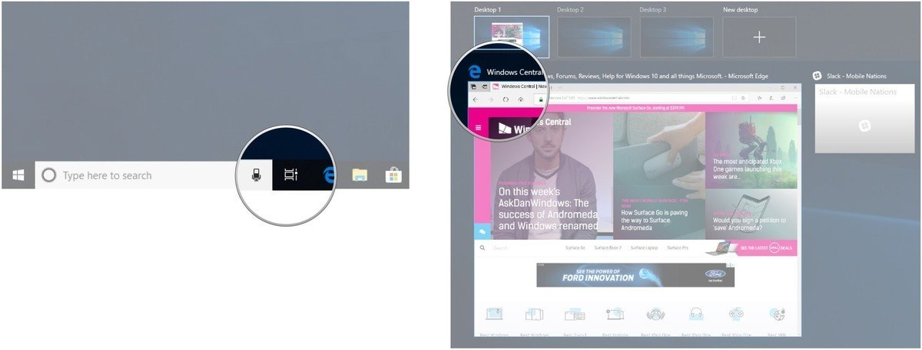](https://www.windowscentral.com/sites/wpcentral.com/files/styles/xlarge/public/field/image/2018/07/windows-10-virtual-desktop-update-duplicate-01.jpeg?itok=xnU3edBo)

1. Click **Show this window on all desktops** to duplicate a single window.
2. Click **Show windows from this app on all desktops** to duplicate all windows from one app.

[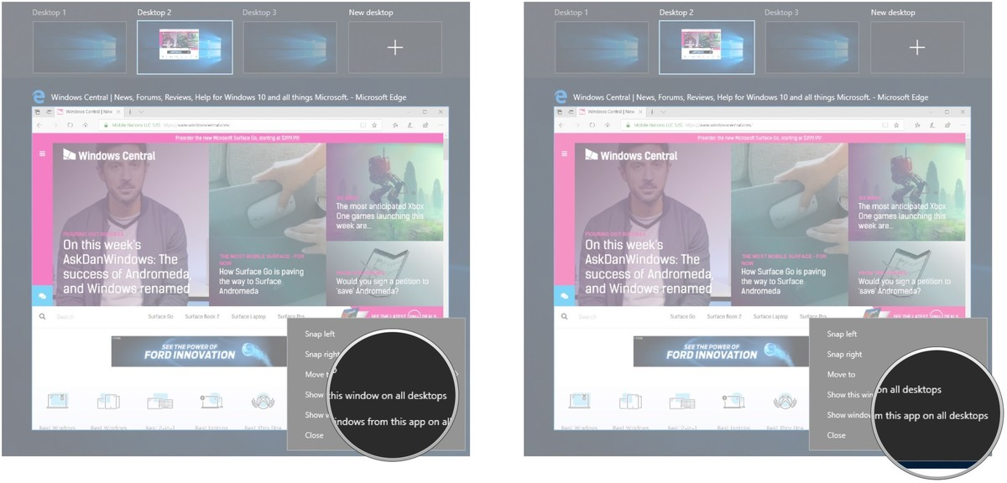](https://www.windowscentral.com/sites/wpcentral.com/files/styles/xlarge/public/field/image/2018/07/windows-10-virtual-desktop-update-duplicate-02.jpeg?itok=Jc56gP1Q)

**How to remove a virtual desktop in Windows 10**

Want to get back to just one desktop? No problem.

1. Click the **Task View** button in your taskbar.
   * You can also use the **Windows key + Tab** shortcut on your keyboard, or you can swipe with one finger from the left of your touchscreen.
2. Hover your **cursor** over the desktop you'd like to remove.
3. Click the **X** in the top-right corner of the desktop icon.

[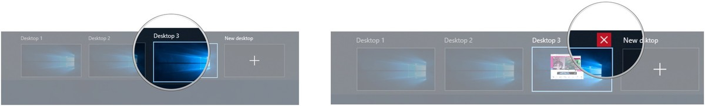](https://www.windowscentral.com/sites/wpcentral.com/files/styles/xlarge/public/field/image/2018/07/windows-10-virtual-desktop-update-delete-01.jpeg?itok=jPIcGlwT)

Open and running windows in a desktop you close will be moved back to your original desktop. You can also use the **Ctrl + Windows key + F4** keyboard shortcut to immediately close the virtual desktop you're currently viewing.